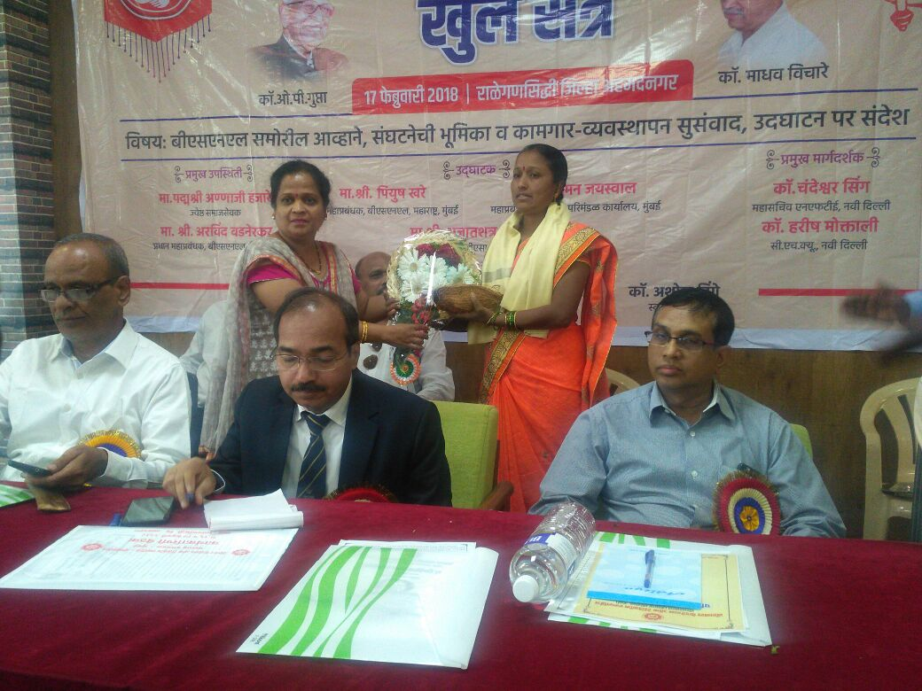
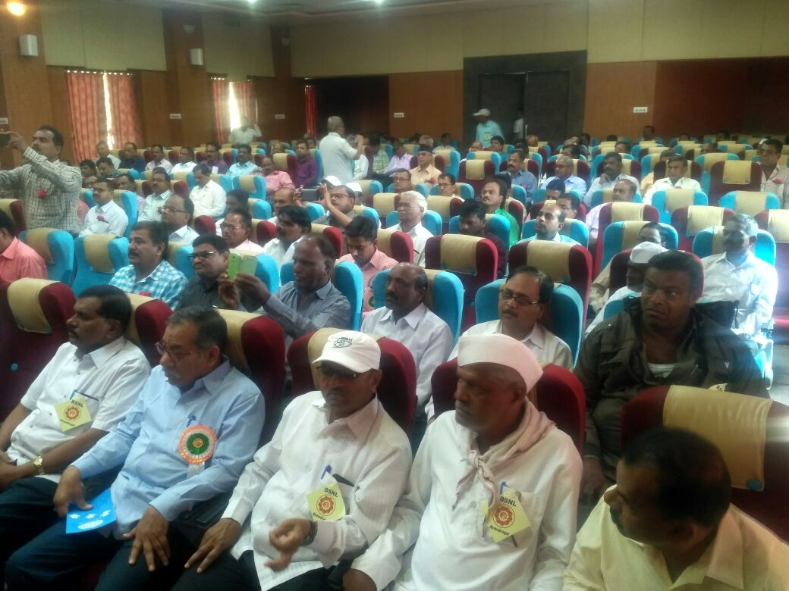
Resolutions
- This CWC extends sincere thanks to CHQ leaders Com.Islam Ahmad President, Com.C.Singh G.S. and Com.K.S.Kulkarni Secretary CHQ for securing pension by removing 60:40 ratio restriction. And fully from consolidated fund of India.
- This CWC extends sincere thanks to Com.C.Singh G.S. and Com.K.S.Kulkarni Secretary CHQ for their efforts to organize united struggle for the issues regarding wage revision and roll back of Tower company formation.
- This CWC resolves that BSNL should start immediate recruitment process for non executive cadre, since there is large scale of retirement.
- This CWC resolves that new technology training should be imparted to non executive employees.(i.e. OFC, Broad Band, Sales & marketing and GSM).
- This CWC resolves that all the workers should get prepared for struggle to protect their rights and BSNL in the interest of the Nation.

